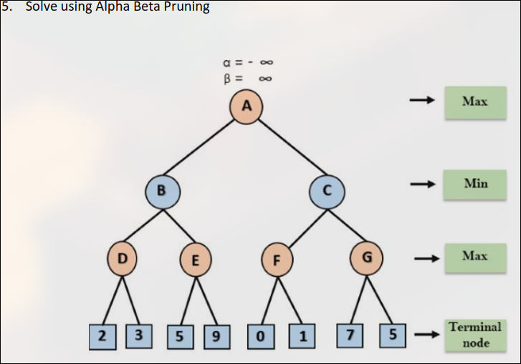
Ans:

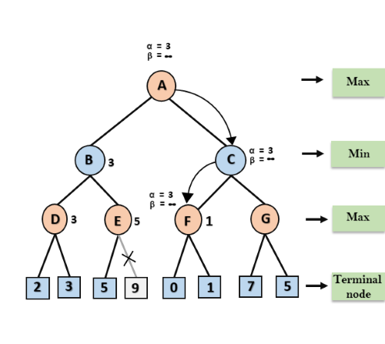

Step 1: Max starts at A (α=-∞, β=+∞), passing values to B and then to D.
Step 2: At D, Max updates α to max(2, 3) = 3, setting node value to 3.
Step 3: Backtracking to B, Min updates β to min(+∞, 3) = 3, setting α=-∞, β=3, then moves to E.
Step 4: At E, Max updates α to max(-∞, 5) = 5, α ≥ β, pruning the right successor; E’s value is 5.
Step 5: Backtracking to A, Max updates α to max(-∞, 3) = 3, passing values (α=3, β=+∞) to C.
Step 6: At F, Max updates α to max(3, 0) = 3, then max(3, 1) = 3, setting node value to 1.
Step 7: Backtracking to C, Min updates β to min(+∞, 1) = 1, α ≥ β, pruning subtree G.
Step 8: C returns 1 to A, Max updates to max(3,1) = 3; the optimal value for Max is 3.

6. Describe Bayesian networks. How are the Bayesian networks powerful representations for
uncertainty knowledge?

"A Bayesian network is a probabilistic graphical model which represents a set of
variables and their conditional dependencies using a directed acyclic graph."

Bayesian networks are probabilistic, because these networks are built from
a probability distribution, and also use probability theory for prediction and anomaly
detection.

Bayesian Network can be used for building models from data and experts opinions,
and it consists of two parts:
o Directed Acyclic Graph
o Table of conditional probabilities.
The generalized form of Bayesian network that represents and solve decision problems
under uncertain knowledge is known as an Influence diagram.

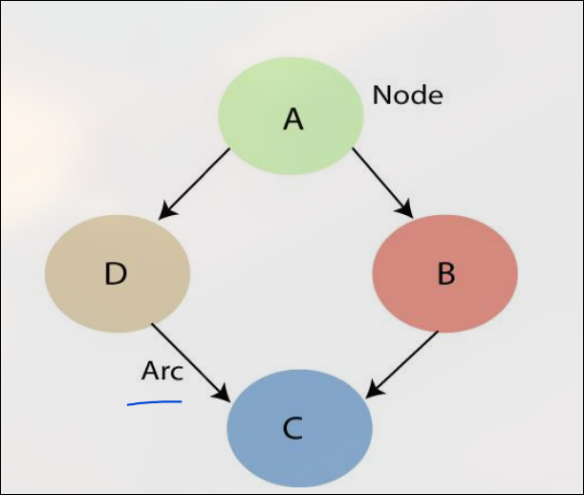

7. Differentiate between Explanation-based learning, learning by analogy, discovery-based learning
,Neural net learning and Genetic Learning . Also describe the respective applications.

1. Explanation-Based Learning (EBL)
EBL is a machine learning method where the system learns by generalizing from a single example using prior domain knowledge. It explains why the example works and extracts the essential features for future use.
Application:
- Medical Diagnosis: Identifying diseases based on prior knowledge of symptoms and causes.
- Robotics: Enhancing robot decision-making based on predefined rules.

2. Learning by Analogy
This approach enables a system to solve new problems by drawing similarities between a known problem and a new situation. The knowledge from the past case is applied to solve the new case.
Application:
- Legal Reasoning: Applying past case rulings to new legal scenarios.
- Tutoring Systems: Teaching problem-solving by drawing analogies to known concepts.

3. Discovery-Based Learning
This method allows an AI system to learn by exploring, experimenting, and discovering patterns without explicit guidance. It promotes independent problem-solving and rule formation.
Application:
- Scientific Research: AI discovering new chemical compounds or drugs.
- Game AI: Learning new strategies by trial and error.

4. Neural Network Learning
Neural networks simulate human brain functioning to learn patterns and representations from large datasets. They use interconnected neurons and adjust weights through backpropagation.
Application:
- Image and Speech Recognition: Identifying objects, faces, and speech patterns.
- Financial Forecasting: Predicting stock market trends based on historical data.

5. Genetic Learning
Inspired by biological evolution, genetic learning uses selection, mutation, and crossover to evolve better solutions over generations.
Application:
- Optimization Problems: Solving NP-hard problems like scheduling and routing.
- Game AI: Evolving optimal strategies in game environments.

8. Explain various member functions used in fuzzy logic. Explain fuzzy controllers.

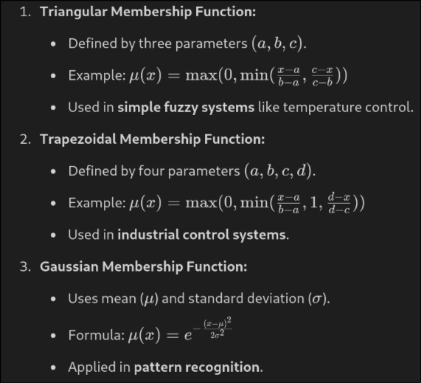

A Fuzzy Logic Controller (FLC) is a system that uses fuzzy logic principles to make decisions based on imprecise inputs.

- Fuzzification: Converts crisp input values into fuzzy values using membership functions.
- Rule Base: A set of IF-THEN rules that define how input variables relate to output variables.
- Inference Engine: Applies fuzzy rules to determine the fuzzy output.
- Defuzzification: Converts fuzzy output back to a crisp value using methods like centroid or mean of maxima.

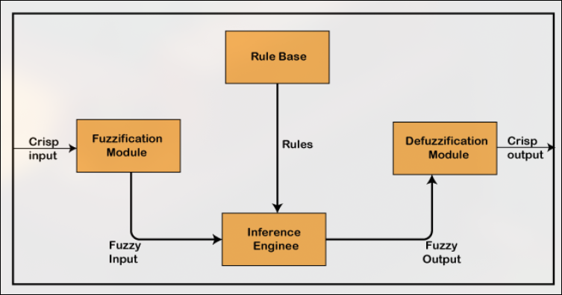

9. What are the various applications of NLP. List the challenges often faced in this domain.

Application:

- Machine Translation – Converting text from one language to another (e.g., Google Translate).
- Chatbots & Virtual Assistants – Powering AI assistants like Siri, Alexa, and customer service bots.
- Speech Recognition – Converting spoken language into text (e.g., voice typing, dictation software).
- Sentiment Analysis – Understanding emotions in text, used in social media monitoring and product reviews.
Challenges:

- Ambiguity – Words and sentences often have multiple meanings (e.g., "bank" as a financial institution or a riverbank).
- Sarcasm & Irony – Difficult for machines to detect tone and intent accurately.
- Lack of Context Understanding – Words may change meaning based on context (e.g., "bat" in sports vs. an animal).
- Data Sparsity – Some languages or domains lack sufficient training data.

10. Explain K- Means clustering along with its pros and cons.

K-Means is an unsupervised machine learning algorithm used for clustering data into K groups based on similarity. It minimizes the variance within clusters by iteratively updating cluster centroids.

Steps in K-Means Algorithm
- Select K: Choose the number of clusters (K).
- Initialize Centroids: Randomly select K points as initial centroids.
- Assign Clusters: Assign each data point to the nearest centroid based on Euclidean distance.
- Update Centroids: Compute the mean of all points in each cluster and update centroids.
- Repeat Steps 3 & 4 until centroids no longer change or a stopping condition is met.

Pros of K-Means
✔ Simple and Fast – Efficient for large datasets with low computational cost.
✔ Scalable – Works well with big data and can be optimized using parallel computing.
✔ Interpretable – Results are easy to understand and visualize.
✔ Guaranteed Convergence – Always converges, though it may be to a local minimum.

Cons of K-Means
❌ Choosing K is Hard – Requires prior knowledge or methods like the elbow method to find the best K.
❌ Sensitive to Outliers – Outliers can significantly affect cluster centroids.
❌ Assumes Spherical Clusters – Struggles with non-linearly separable or irregularly shaped clusters.
❌ Local Minima Issue – May converge to suboptimal solutions based on initial centroids.

11. Explain the importance of machine learning in artificial intelligence. Differentiate between the
following:
i) Supervised and unsupervised learning
ii) Classification and clustering
Machine learning (ML) is a core subset of artificial intelligence (AI) that enables systems to learn from data and make decisions without explicit programming. It enhances AI by:
- Improving Decision-Making: ML models analyze vast amounts of data to make accurate predictions.
- Automation: Reduces the need for manual intervention by learning patterns and optimizing processes.
- Enhancing Personalization: Powers recommendation systems (e.g., Netflix, Amazon).

i) Supervised vs. Unsupervised Learning
Supervised Learning | Unsupervised Learning
Learns from labeled data (input-output pairs). | Learns from unlabeled data without predefined categories.
Eg. Linear Regression, Decision Trees, Neural Networks | K-Means, DBSCAN, PCA
Purpose: Predict outcomes based on past data. | Discover hidden patterns and structures.
Usecase: Spam email detection (spam/not spam). | Customer segmentation (grouping similar customers).

ii) Classification vs. Clustering
Classification | Clustering
Categorizes data into predefined labels. | Groups similar data points without predefined labels.
Supervised Learning | Unsupervised Learning
Eg of algo: Decision Trees, SVM, Naïve Bayes | K-Means, DBSCAN, Hierarchical Clustering
Output: Discrete labels (e.g., spam or not spam). | Clusters of similar data points (e.g., customer groups).
Usecase: Classifying emails as spam or not. | Segmenting customers based on purchasing behavior.
12. Differentiate between syntax analysis and semantic analysis in NLP with examples.

Syntax Analysis | Semantic Analysis
Focuses on the grammatical structure of a sentence. | Focuses on the meaning of words and sentences.
Ensures that a sentence follows linguistic rules. | Ensures that a sentence conveys a meaningful interpretation.
Example: "He go to school" is incorrect due to subject-verb agreement error. | Example: "The car ate the sandwich" is syntactically correct but semantically meaningless.
Uses techniques like parsing, context-free grammar, and part-of-speech tagging. | Uses techniques like word sense disambiguation, named entity recognition, and relation extraction.
Helps in detecting grammatical errors in text. | Helps in understanding intent, context, and relationships in text.

13. Explain the role of tokenization, stemming, and lemmatization in NLP

Role of Tokenization, Stemming, and Lemmatization in NLP
- Tokenization
  - The process of breaking text into smaller units (tokens), such as words or sentences.Role: Helps NLP models process text efficiently by converting it into manageable components.
  - Example:
    - Input: "Natural Language Processing is amazing!"
    - Tokenized Output: ["Natural", "Language", "Processing", "is", "amazing", "!"]
- Stemming
  - Definition: Reducing words to their root or base form by removing suffixes, often using rule-based truncation.Role: Reduces word variations to improve text processing while reducing complexity.
  - Example:
    - Input: "running", "runs", "runner"
    - Stemmed Output: "run"
- Lemmatization
  - Definition: Converts words to their dictionary (lemma) form using linguistic rules.Role: Provides a more accurate base form than stemming, preserving meaning.
  - Example:
    - Input: "running", "ran", "better"
    - Lemmatized Output: "run", "run", "good"

